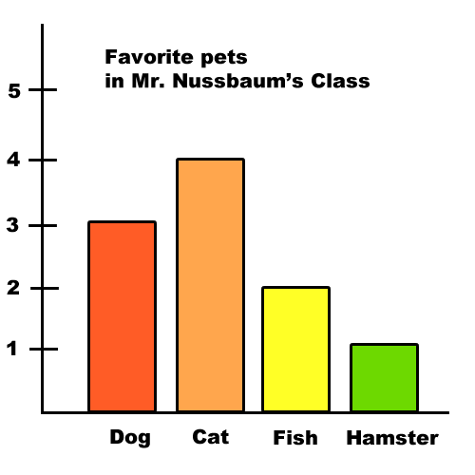 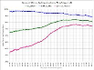[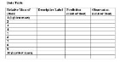](http://www.google.com/imgres?q=data+table&start=164&hl=en&tbo=d&biw=1024&bih=587&tbm=isch&tbnid=vwEIkP8BQ2sK-M:&imgrefurl=http://www.laep.org/target/technology/secondary/density_lesson/activity_1.html&docid=j2iemYf8PNSr2M&imgurl=http://www.laep.org/target/technology/secondary/density_lesson/charts/data_table.gif&w=693&h=357&ei=Dkb0ULL_B9OK2QWu_IC4Aw&zoom=1&iact=rc&dur=3&sig=101627834528739578745&page=10&tbnh=138&tbnw=275&ndsp=17&ved=1t:429,r:74,s:100,i:226&tx=242&ty=93)

Variables

Hypothesis

Testable Question

Data Tables, Photos, Graphs

Numbered Procedures

ETC.

Specific Materials

Project Title

Data Analysis and Results

Conclusion

Application